Academic Year | 2025 - 26 | Experiment No. | 2
Course & Semester | S.E. – Sem. IV | Subject Name | Web Programming
Experiment Type | Software Performance | Subject Code | 25VSE12CS03

Name of Student: | Atharva Dharmendra Jagtap | Roll No.: | 10937
Date of Performance: | 09-02-2026 | Date of Submission: | 09-02-2026
LO Mapping | 25VSE12CS03.2: Apply JavaScript, HTML5 and CSS3 effectively to create interactive and dynamic websites.

Indicator | Poor | Average | Good
Timeline Maintains submission deadline (3) | Submission not done (0) | One or More than One week late (1-2) | Maintains deadline (3)
Completion and Organization (3) | N/A | Document is just acceptable (1-2) | Completed whole document and neatly organized (3)
Program Performance (2) | Could not perform at all (0) | Implemented few parts (1) | Full implementation (2)
Knowledge In depth knowledge of the Experiment (2) | Unable to answer questions (0) | Unable to answer few questions (1) | Able to answer all questions (2)

Assessment Marks:
Timeline
Completion and Organization
Program Performance
Knowledge

Total: (Out of 10)
Teacher’s Sign: Student Sign:

Experiment No. 2
- Aim:
Apply the styles (CSS3- inline, internal and external) to web page (APPLY COLOR, BACKGROUND-COLOUR/IMAGE, FONT STYLES, TABLE STYLES, LIST STYLES).

- Objective:
The objective of this problem statement is to Understand CSS Styling methods.To Apply various styles to improve the visual appeal of the web page, including colors, backgrounds, fonts, tables, and lists.The goal is to promote code reusability, achieve design consistency , prepare for real world development.

- Theory:
CSS is the language we use to style an HTML document. CSS describes how HTML elements should be displayed.CSS (Cascading Style Sheets) is a styling language used to define the layout and presentation of HTML.(Hypertext Markup Language) and XML (Extensible Markup Language) documents. It is used to add colors, fonts, spacing, and other design elements to web pages. CSS allows you to separate the content of a web page from its presentation, making it easier to maintain and update.
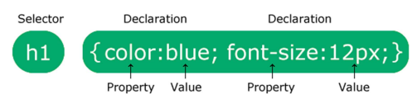
The selector points to the HTML element you want to style.The declaration block contains one or more declarations separated by semicolons.Each declaration includes a CSS property name and a value, separated by a colon.Multiple CSS declarations are separated with semicolons, and declaration blocks are surrounded by curly braces.
TYPES:
There are three types of CSS:
Inline CSS: is used to style individual HTML elements. You can add CSS styles to an HTML element by using the style attribute and specifying the CSS properties and values within it. Here's an example:
<p style="color: red; font-size: 20px;">This is a paragraph with inline CSS</p>
Internal CSS: Internal CSS is used to style a group of HTML elements within a single web page. You can add CSS styles to the head section of an HTML document by using the style element and specifying the CSS properties and values within it. Here's an example:
<head>
<title>Internal CSS Example</title>
<style>
p {
color: red;
font-size: 20px;
}
</style>
</head>

External CSS: is used to style multiple web pages. You can create a separate CSS file with all the styles and link it to your HTML document using the link element in the head section of the HTML document.
Here's an example:
<head>
<title>External CSS Example</title>
<link rel="stylesheet" type="text/css" href="style.css">
</head>
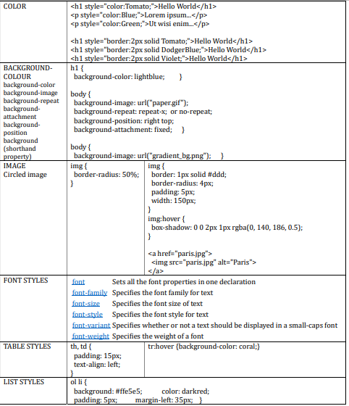

- Implementation:
Lab1.html
<!DOCTYPE html>
<html lang="en">
<head>
<meta charset="UTF-8">
<meta name="viewport" content="width=device-width, initial-scale=1.0">
<title>Atharva Jagtap | Portfolio</title>

<!-- Google Fonts -->
<link href="https://fonts.googleapis.com/css2?family=Inter:wght@400;500;600;700&family=Playfair+Display:wght@700&display=swap" rel="stylesheet">
<link rel="stylesheet" href="Lab1.css">
</head>
<body>

<nav>
<div class="container">
<a href="#" class="logo">AJ.</a>
<div class="nav-links">
<a href="#about">About</a>
<a href="#experience">Experience</a>
<a href="#projects">Projects</a>
<a href="#contact">Contact</a>
</div>
</div>
</nav>

<header class="hero">
<div class="container">
<div style="display: flex; gap: 50px; align-items: center; flex-direction: row;">
<img src="https://atharva9167j.github.io/profile.png" alt="Atharva Jagtap" class="profile-pic">
<div>
<span class="tag" style="background: var(--accent-beige); color: white;">Available for Freelance</span>
<h1>Atharva <span>Jagtap</span></h1>
<p>Full-Stack Developer & AI Specialist. Crafting intelligent, high-performance digital experiences with Python, Node.js, and React.</p>
<a href="#contact" class="btn">Get in touch</a>
</div>
</div>
</div>
</header>

<section id="about" class="container">
<h2 class="section-title">About Me</h2>
<div style="display: flex; gap: 50px; align-items: center; flex-wrap: wrap;">
<div style="flex: 1; min-width: 300px;">
<p>Results-driven Computer Science Engineer with over 3 years of experience. I specialize in end-to-end development — from crafting efficient back-end APIs to integrating advanced AI models.</p>
<br>
<p>As a <strong>Google Developer Program Member</strong>, I thrive at the intersection of clean architecture and next-generation AI integration.</p>
</div>
<div style="flex: 1; min-width: 300px;">
<div class="grid" style="grid-template-columns: 1fr 1fr;">
<div class="card" style="padding: 20px; text-align: center;">
<h3 style="color: var(--accent-beige); font-size: 2.5rem;">3+</h3>
<p>Years Experience</p>
</div>
<div class="card" style="padding: 20px; text-align: center;">
<h3 style="color: var(--accent-beige); font-size: 2.5rem;">50+</h3>
<p>Projects Done</p>
</div>
</div>
</div>
</div>
</section>

<section id="experience" style="background: #f3f0ec;">
<div class="container">
<h2 class="section-title">Experience</h2>
<div class="grid">
<div class="card">
<span class="tag">Current</span>
<h3>Freelance Developer</h3>
<p style="font-weight: 600; color: var(--accent-beige);">Sep 2024 - Present</p>
<p>Developing responsive web and mobile applications using React Native/Expo. Assisting clients with scalable back-end solutions and AI integrations.</p>
</div>
<div class="card">
<span class="tag">Ex-Intern</span>
<h3>Edba Academy</h3>
<p style="font-weight: 600; color: var(--accent-beige);">Apr 2024 - June 2025</p>
<p>Optimized UI/UX by 20% and improved load times by 15%. Integrated Gemini APIs to enhance AI features for learning platforms.</p>
</div>
</div>
</div>
</section>

<section id="projects" class="container">
<h2 class="section-title">Selected Projects</h2>
<div class="grid">
<!-- Project 1 -->
<div class="card">
<div class="tag">Mobile App</div>
<h3>Glyphify</h3>
<p>Cutting-edge mobile application designed for education management using React Native and Google Generative AI.</p>
<div style="margin-top: 20px;">
<span class="skill-pill">React Native</span>
<span class="skill-pill">AI API</span>
</div>
</div>
<!-- Project 2 -->
<div class="card">
<div class="tag">AI Tool</div>
<h3>Designo</h3>
<p>GenAI-powered Figma plugin that streamlines design workflows using Python Flask and Google Agent Dev Kit.</p>
<div style="margin-top: 20px;">
<span class="skill-pill">Python</span>
<span class="skill-pill">Tailwind</span>
</div>
</div>
<!-- Project 3 -->
<div class="card">
<div class="tag">Platform</div>
<h3>SkillsElevate</h3>
<p>AI-driven learning platform enhancing quantitative and logical reasoning skills for students.</p>
<div style="margin-top: 20px;">
<span class="skill-pill">Node.js</span>
<span class="skill-pill">Firebase</span>
</div>
</div>
</div>
</section>

<section id="skills" class="container">
<h2 class="section-title">Technical Expertise</h2>
<div class="skills-container">
<span class="skill-pill">React.js</span>
<span class="skill-pill">Node.js</span>
<span class="skill-pill">Python</span>
<span class="skill-pill">TypeScript</span>
<span class="skill-pill">Next.js</span>
<span class="skill-pill">Gemini APIs</span>
<span class="skill-pill">Postman</span>
<span class="skill-pill">Firebase</span>
<span class="skill-pill">Google Cloud Platform</span>
<span class="skill-pill">Express.js</span>
<span class="skill-pill">RESTful APIs</span>
</div>
</section>

<section id="contact" style="background: var(--white);">
<div class="container" style="max-width: 600px; text-align: center;">
<h2 class="section-title">Let's Connect</h2>
<p>Ready to bring your ideas to life? Drop me a message.</p>
<br>
<form>
<input type="text" placeholder="Name" required>
<input type="email" placeholder="Email" required>
<textarea rows="5" placeholder="Your Message"></textarea>
<button type="submit" class="btn" style="width: 100%; border: none; cursor: pointer;">Send Message</button>
</form>
<div style="margin-top: 40px; color: var(--text-muted);">
<p>📍 Virar, Maharashtra, India</p>
<p>📞 +91 7066935597</p>
</div>
</div>
</section>

<footer>
<div class="container">
<p>© 2026 Atharva Jagtap. Built with precision and care.</p>
</div>
</footer>

</body>
</html>

Lab1.css
/* Custom Properties for consistency */
:root {
--bg-color: #faf9f6; /* Off-white/Bone */
--text-main: #1a1a1a; /* Deep Charcoal */
--text-muted: #666666;
--accent-beige: #d4b996; /* Rich Beige */
--accent-light: #eaddca; /* Light Beige */
--white: #ffffff;
--shadow: 0 10px 30px rgba(0,0,0,0.05);
--transition: all 0.3s ease;
}

* {
margin: 0;
padding: 0;
box-sizing: border-box;
font-family: 'Inter', -apple-system, sans-serif;
}

html {
scroll-behavior: smooth;
}

body {
background-color: var(--bg-color);
color: var(--text-main);
line-height: 1.7;
}

h1, h2, h3 {
font-family: 'Playfair Display', serif;
font-weight: 700;
}

/* --- Layout --- */

.container {
max-width: 1100px;
margin: 0 auto;
padding: 40px 20px;
}

section {
padding: 100px 0;
}

/* --- Navigation --- */

nav {
position: fixed;
top: 0;
width: 100%;
background: rgba(250, 249, 246, 0.9);
backdrop-filter: blur(10px);
z-index: 1000;
padding: 20px 0;
border-bottom: 1px solid rgba(0,0,0,0.05);
}

nav .container {
display: flex;
justify-content: space-between;
align-items: center;
}

.logo {
font-family: 'Playfair Display', serif;
font-size: 1.5rem;
font-weight: bold;
color: var(--text-main);
text-decoration: none;
}

.nav-links a {
text-decoration: none;
color: var(--text-main);
margin-left: 30px;
font-size: 0.9rem;
font-weight: 500;
text-transform: uppercase;
letter-spacing: 1px;
transition: var(--transition);
}

.nav-links a:hover {
color: var(--accent-beige);
}

/* --- Hero Section --- */
.profile-pic {
width: 300px;
height: 300px;
border-radius: 50%;
object-fit: cover;
border: 4px solid var(--accent-beige);
}

.hero {
height: 100vh;
display: flex;
align-items: center;
background: linear-gradient(135deg, #fdfbfb 0%, #ebedee 100%);
}

.hero h1 {
font-size: 4rem;
line-height: 1.1;
margin-bottom: 20px;
}

.hero span {
color: var(--accent-beige);
}

.hero p {
font-size: 1.2rem;
color: var(--text-muted);
max-width: 600px;
margin-bottom: 30px;
}

.btn {
display: inline-block;
padding: 15px 35px;
background: var(--accent-beige);
color: white;
text-decoration: none;
border-radius: 4px;
transition: var(--transition);
font-weight: 600;
}

.btn:hover {
background: #c2a684;
transform: translateY(-3px);
}

.section-title {
font-size: 2.5rem;
margin-bottom: 50px;
position: relative;
display: inline-block;
}

.section-title::after {
content: '';
position: absolute;
bottom: -10px;
left: 0;
width: 50px;
height: 3px;
background: var(--accent-beige);
}

.grid {
display: grid;
grid-template-columns: repeat(auto-fit, minmax(300px, 1fr));
gap: 30px;
}

.card {
background: var(--white);
padding: 40px;
border-radius: 12px;
box-shadow: var(--shadow);
transition: var(--transition);
border: 1px solid rgba(0,0,0,0.02);
}

.card:hover {
transform: translateY(-10px);
}

.card h3 {
margin-bottom: 15px;
}

.tag {
display: inline-block;
background: var(--accent-light);
color: #8a7051;
padding: 4px 12px;
border-radius: 20px;
font-size: 0.75rem;
font-weight: 700;
margin-bottom: 10px;
}

/* --- Skills List --- */

.skills-container {
display: flex;
flex-wrap: wrap;
gap: 15px;
}

.skill-pill {
background: var(--white);
border: 1px solid var(--accent-beige);
padding: 8px 20px;
border-radius: 50px;
font-size: 0.9rem;
transition: var(--transition);
}

.skill-pill:hover {
background: var(--accent-beige);
color: white;
}

/* --- Form --- */

input, textarea {
width: 100%;
padding: 15px;
margin-bottom: 20px;
border: 1px solid #ddd;
border-radius: 8px;
background: #fdfdfd;
}

input:focus, textarea:focus {
outline: none;
border-color: var(--accent-beige);
}

footer {
padding: 50px 0;
text-align: center;
background: var(--text-main);
color: var(--accent-light);
}

@media (max-width: 768px) {
.hero h1 { font-size: 2.5rem; }
.nav-links { display: none; } /* Simplified for demo */
}
- Output:
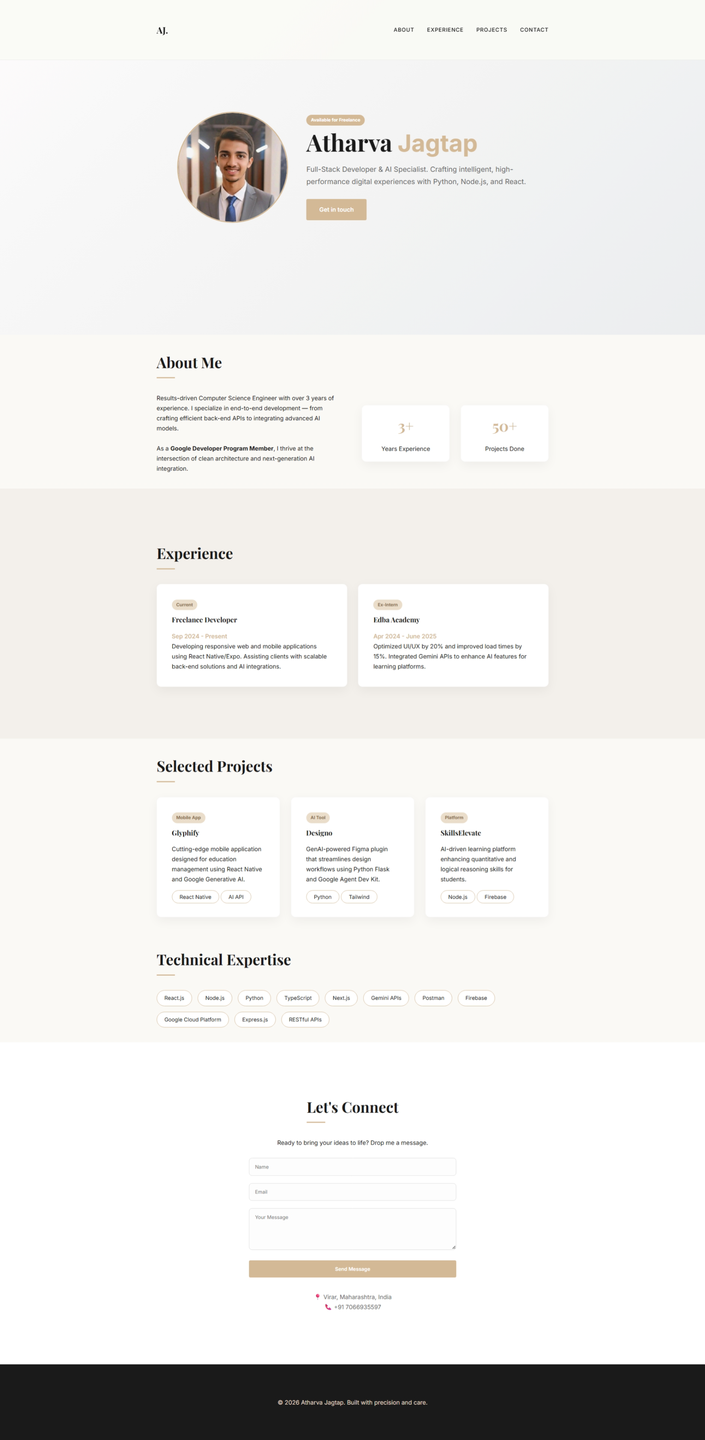

Post Lab Question :
- How can you apply a background image to a web page using CSS? What properties can you use to control its appearance (e.g., size, repeat, position)?

Sol.
Use the background-image property.
body{
background-image:url("background.jpg");
}

Key Properties:
Property | Purpose
background-size | Controls scaling (cover, contain)
background-repeat | Prevent tiling (no-repeat)
background-position | Align image (center, top)
background-attachment | Fixed or scroll behavior
Example:
body{
background-image:url("bg.jpg");
background-size:cover;
background-repeat:no-repeat;
background-position:center;
}

- What are the benefits of using external CSS files?
Sol.
• Code Reusability: One stylesheet can style multiple pages.
• Consistency: Maintains uniform design across a website.
• Faster Loading: Browser caches CSS files.
• Cleaner HTML: Separates structure from presentation.
• Simplified Maintenance: Edit one file to update the entire site.

- How can you apply different font styles to text elements using CSS? List and describe at least three font-related properties.
Sol. Common Font Properties:
Property | Description | Example
font-family | Defines typeface | font-family: Arial;
font-size | Controls text size | font-size:18px;
font-weight | Sets thickness | font-weight:bold;
font-style | Italic or normal | font-style:italic;
letter-spacing | Space between characters | letter-spacing:2px;
Example:
p{
font-family:Verdana;
font-size:16px;
font-weight:500;
}

- Conclusion:
This experiment demonstrates the structured application of CSS using inline, internal, and external methods to enhance visual presentation while preserving maintainability.
Key outcomes:
- Separation of content and styling improves scalability.
- External CSS promotes reusable design patterns.
- Internal CSS enables page-specific styling.
- Inline CSS supports quick overrides.
- Fonts, colors, tables, and lists significantly improve readability and professionalism.
The resulting portfolio reflects modern development practices and is suitable for real-world deployment with minimal modification.

